PRESS RELEASE
For Additional Information
Please contact info@kopeikingallery.com
t. 310.385.5894

HIROSHI WATANABE
IDEOLOGY IN PARADISE
June 6 - July 11, 2009
Opening Reception and Book Signing, Saturday, June 6, 7 - 9 pm

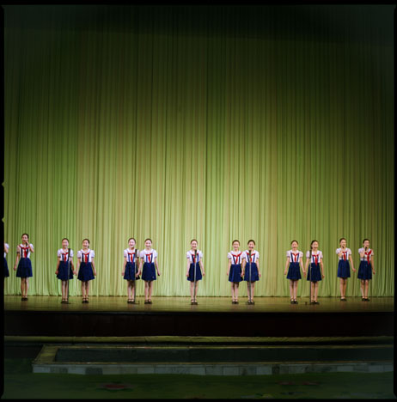
The Kopeikin Gallery is pleased to present an exhibition by Japanese born and Los Angeles based photographer, Hiroshi Watanabe titled Ideology in Paradise (also the title of Watanabe’s recently published book). While widely exhibited internationally this is Watanabe’s first solo show at the Kopeikin Gallery. Putting aside his usual black and white palette, Watanabe this time uses color in his attempt to tell an unbiased story of North Korean culture and everyday life. The exhibition opens on Saturday, June 6th with a book signing and reception with the artist from 7:00 – 9:00. The exhibition will continue through July 11th. The gallery’s summer hours are Wednesday through Saturday from 11:00 – 5:00. It is free and open to the public.

From 2006 – 2007, Watanabe made trips to North Korea to investigate the myths that were spoken as fact in his native Japan. North Korea was described only as a country that kidnapped Japanese, allowed police to brutalize their citizens, and left the poor to die of starvation on the streets. Unconvinced by this one-sided perspective of North Koreans he wanted to investigate for himself. During his time in North Korea, he let his curiosity guide him and allowed the process to unfold organically without imposing any agenda. These images are rich in both content and aesthetics, giving the viewer a window into a moment in time, captured with a genuine respect that is visible in each of his images.

As Lesley Martin writes, “… the experience of looking at Hiroshi Watanabe’s images is eerily like stepping into a Social Realist painting: the ruddy-cheeked young girl playing the accordion, the traditional gowns in brilliant pinks and greens of dancers swirling beneath the omnipresent image of the dear leader and the DPRK flag. One is quietly lulled into the sense that life in North Korea might, in fact, be just as it appears within the frames of these images—normal—instead of like the stories of kidnappings, military posturing, and famine.”

Hiroshi Watanabe lives and works in Los Angeles and holds a degree from Nihon University, Japan. He has published eight books of his work and he is in the permanent collections of the Philadelphia Museum of Art, the Houston Museum of Fine Arts, The George Eastman House and the Santa Barbara Museum of Art. Watanabe’s recent accomplishments include the Hearst 8 x 10 Biennial Award, the Center Project Competition First Prize, and the Photolucida Critical Mass Book Award.

The Kopeikin Gallery is located at 8810 Melrose Avenue, West Hollywood, CA, 90069. Hours: Wednesday – Saturday 11 am – 5 pm.
Image: Hiroshi Watanabe, Singers, Mangyondae Schoolchildren’s Palace, North Korea, Archival Pigment Print, 2007.

